Contents

**Vaisakhi: A Celebration of Harvest and History** 1

**Introduction** 1

**Historical Background** 1

**Agricultural Significance** 1

**The Birth of the Khalsa (1699)** 1

**Celebrations Across Regions**In Punjab, the heartland of Vaisakhi celebrations, people gather at **Gurdwaras** (Sikh temples), participate in processions known as **Nagar Kirtans**, and perform **Seva** (selfless service). Key Gurdwaras such as **Golden Temple (Amritsar)** and **Takht Sri Kesgarh Sahib (Anandpur Sahib)** see massive gatherings. Outside India, Sikh communities in the UK, Canada, and the US also celebrate Vaisakhi with parades and community service. 1

**Conclusion** 2

**Vaisakhi: A Celebration of Harvest and History**

**Introduction**

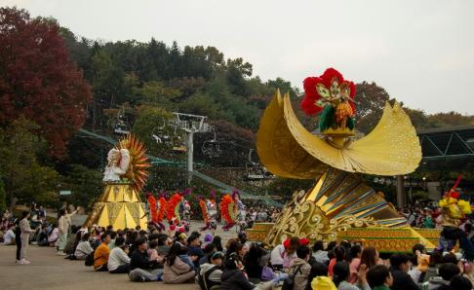Vaisakhi, also known as Baisakhi, is one of the most significant festivals celebrated in northern India, especially in Punjab. Observed annually on April 13 or 14, it marks the Punjabi New Year and the beginning of the harvest season. However, for Sikhs, Vaisakhi carries even deeper religious importance—it commemorates the formation of the **Khalsa** in 1699 by **Guru Gobind Singh Ji**, the tenth Sikh Guru. This festival is not only a joyous agricultural celebration but also a pivotal moment in Sikh religious history.

**Historical Background**

**Agricultural Significance**

In agrarian communities, Vaisakhi is a time to express gratitude for a bountiful harvest. Farmers in Punjab and surrounding regions harvest **Rabi crops**, such as wheat, and offer thanks to God for prosperity. The day is marked by vibrant celebrations, traditional dances like **Bhangra** and **Gidda**, and community fairs.

**The Birth of the Khalsa (1699)**

The spiritual significance of Vaisakhi for Sikhs originates from an important event in **Anandpur Sahib**. On Vaisakhi day in 1699, **Guru Gobind Singh Ji** called thousands of Sikhs to a gathering. In a dramatic and bold act, he asked for volunteers willing to give their lives for their faith. One by one, five men stepped forward. Instead of being harmed, they were honored and given a new identity. They came to be known as the **Panj Pyare** (the Five Beloved Ones).

Guru Gobind Singh Ji then established the **Khalsa Panth**, a collective body of initiated Sikhs committed to righteousness, equality, and justice. He introduced the **Five Ks** (Kesh, Kara, Kanga, Kachera, and Kirpan), which remain integral to Sikh identity today.

**Celebrations Across Regions**

In Punjab, the heartland of Vaisakhi celebrations, people gather at **Gurdwaras** (Sikh temples), participate in processions known as **Nagar Kirtans**, and perform **Seva** (selfless service). Key Gurdwaras such as **Golden Temple (Amritsar)** and **Takht Sri Kesgarh Sahib (Anandpur Sahib)** see massive gatherings. Outside India, Sikh communities in the UK, Canada, and the US also celebrate Vaisakhi with parades and community service.

Hindus in northern India celebrate Vaisakhi as part of the **solar new year**. In Kerala, it is known as **Vishu**, in Assam as **Rongali Bihu**, and in Tamil Nadu as **Puthandu**.

**Conclusion**

Vaisakhi is a multifaceted festival that blends spiritual awakening, historical remembrance, and agricultural joy. While it celebrates the beginning of a new harvest and year, its deeper significance lies in the courage and unity that gave birth to the Khalsa. Today, Vaisakhi continues to inspire people to uphold the values of community service, equality, and devotion

**References**

1. Singh, Khushwant. *A History of the Sikhs*. Oxford University Press, 2004.
2. Grewal, J. S. *The Sikhs of the Punjab*. Cambridge University Press, 1998.
3. Encyclopaedia Britannica. "Vaisakhi." <https://www.britannica.com/topic/Vaisakhi>
4. BBC Religions. "Vaisakhi (Baisakhi)." <https://www.bbc.co.uk/religion/religions/sikhism/holydays/vaisakhi.shtml>